Sign In/Out System

(Based on Google Form and Appscript )

**System Navigation** **2**

**Note for Moderators** **3**

Sign a student In : 3

Resetting Phones Availability Status : 3

Inserting Names of School Phone Borrowers : 4

**Note for Overnight/Extended Stay Manager** **5**

**Features** **6**

**Sharing and Permission** **6**

**Type of Error Messages** **6**

**Banning Student from Signing Out** **7**

**Data Reset Schedule** **8**

# 

# System Navigation

The system is created based on Google Form, Google Spreadsheet and Google App Script.

Customers :

1. End users : Students
2. Moderators : Faculty on duty
3. Administrators

Actions:

**Sign Out** (User)

1. Users submit sign out requests by filling out the [Google form](https://docs.google.com/forms/d/e/1FAIpQLSdeK77lL3_hKbYuiPP0u_zpTLzU7sjdXKhb6Wg3KphoFU8ANQ/viewform?usp=sf_link)
2. All the information will be submitted to be processed
3. If overnight stay, system will check if permission has been granted by overnight/extended absence manager.
4. No : The response will be “Permission has not been granted, see Overnight/Extended stay manger”
5. Yes : Sign out successful, user info will be listed in “Sign Out Students” sheet in response [spreadsheet](https://docs.google.com/spreadsheets/d/1lZSRojvejiyiv7eRQzMEKhIkGCUVNoapxST3Wrz6VqE/edit?usp=sharing).
6. System will also check if the users have already signed out once
   * 1. Yes : The response will be “Sign Out failed, sign in first.”
     2. No : Sign out successful, user info will be listed in “Sign Out Students” sheet in response [spreadsheet](https://docs.google.com/spreadsheets/d/1lZSRojvejiyiv7eRQzMEKhIkGCUVNoapxST3Wrz6VqE/edit?usp=sharing).

**Sign In** (User)

1. Users submit sign in request by filling out the same [Google form](https://docs.google.com/forms/d/e/1FAIpQLSdeK77lL3_hKbYuiPP0u_zpTLzU7sjdXKhb6Wg3KphoFU8ANQ/viewform?usp=sf_link)
2. User choose their name from options which are auto-generated from “Sign Out Students” sheet.
3. All the information will be submitted to be processed.
4. User’s name will be deleted from “Sign Out Students” sheet and “overnight trip permission” sheet as well if it is an overnight trip.

**Sign in Reminder Service** (System)

1. The system will check “Sign Out Students” sheet every hour to find those who are 1 hour late and still have not signed back in.
2. The system will send a reminder email to those students to sign in or contact the teacher in charge / advisor as the situation warrants.

*Limitation and potential issues:*

1. The *phone list* and *student sign in list* on the form get update every time the form get submitted. The form cannot get updated immediately when students are filling the form. Therefore, if many students are filling the form at the same time, they might not see the most updated phone data on the form.
2. Borrowing Phone: Please refer to ***“School Phone”*** sheet for the information regarding the names of borrowers instead of “***Form Responses***” sheet since the latter contains all the requests including the unsuccessful ones.

# Note for Moderators

* Any modifications on any of these files will result in system failure. Therefore, all the important range on spreadsheet will be protected from editing.
* Information about students who sign out can be found in “Sign Out Students” sheet.

## Sign a student In :

If a teacher wishes to sign a student in, please select the student name or any column in the same row and then click the ***Sign in*** button.

Note: After signing a student in using this method, a “Failed, Already signed in” message will shows up when the student submit another sign in request.

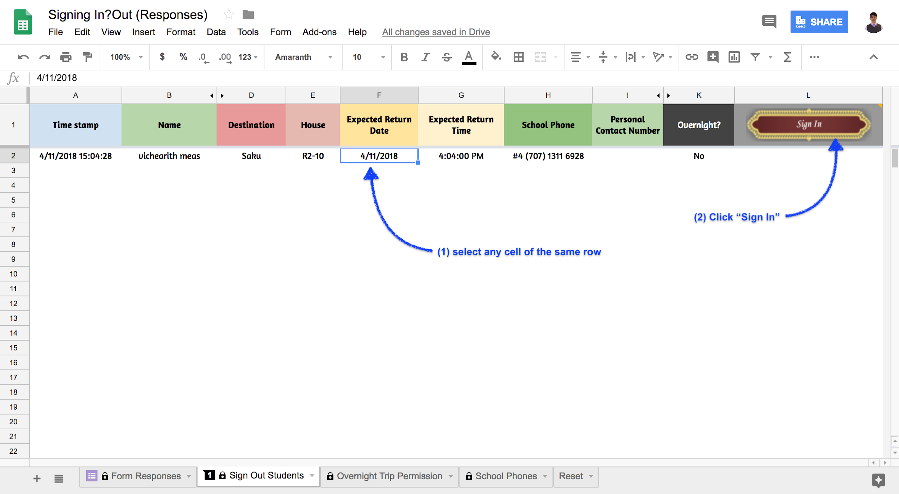

## Resetting Phones Availability Status :

When A student return a school phone, a faculty/staff can reset the availability status in ***School Phones*** sheet.

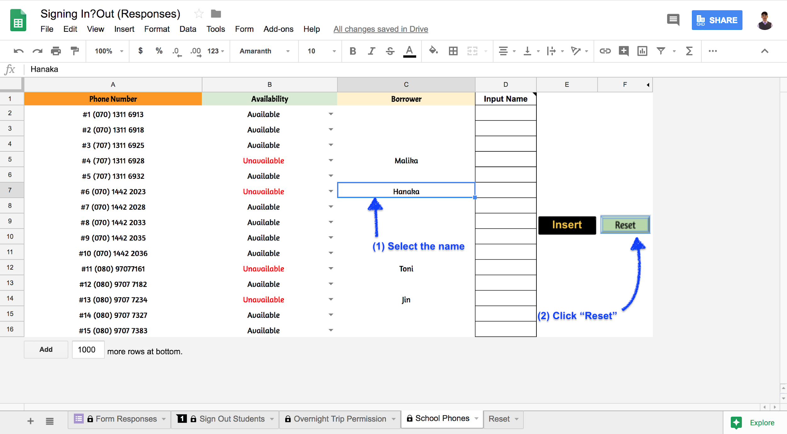

## Inserting Names of School Phone Borrowers :

# Note for Overnight/Extended Stay Manager

Students’ ***Emails*** whose overnight trip permission have been approved need to be added to “Overnight Trip Permission” on [spreadsheet](https://docs.google.com/spreadsheets/d/1lZSRojvejiyiv7eRQzMEKhIkGCUVNoapxST3Wrz6VqE/edit?usp=sharing) for the verification process.

Verification failure will result in students receiving a notification email as shown below:

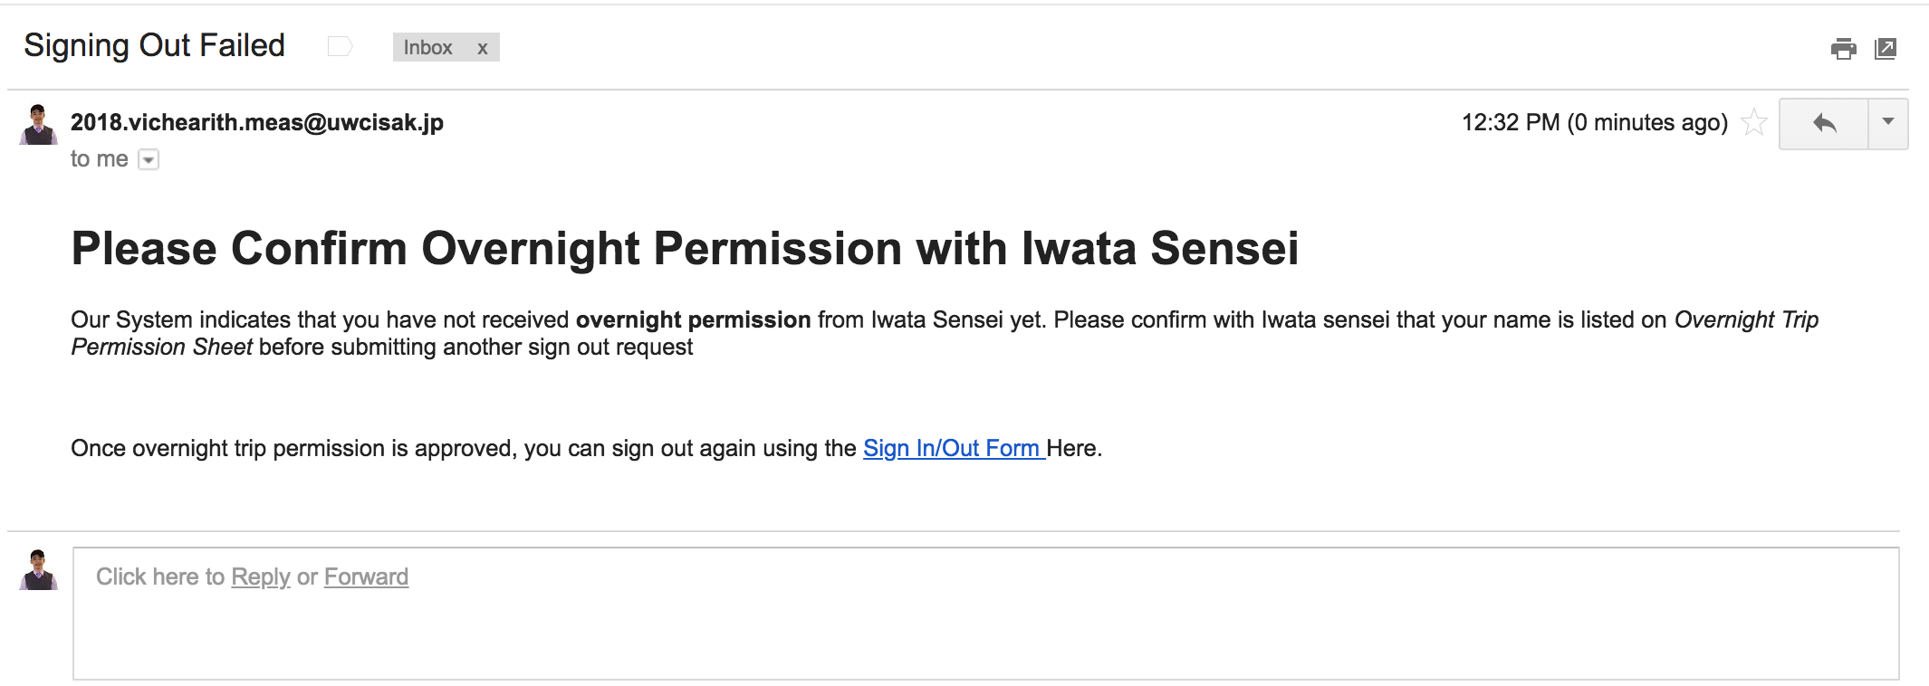

# 

# Features

- **Auto-generates data:** about people who sign out on “Sign Out Students” sheet;

- **One email, one name :** students can only sign in/out for themselves using their email;

- **Reminder Emailing :** auto-generated email will be sent to those who is 1 hours late and still have not signed in.

-**Overnight Trip Permission Check.**

**-Banning students from signing out**

# Sharing and Permission

App script requires permission and authorization from moderators who are using the spreadsheet to operate.

The Script operates on ***both*** the Google form and the Spreadsheet. Therefore, please share both the Google Form and the Spreadsheet with moderators with permission to **Edit**. The easiest way is to share the entire folder.

# Type of Error Messages

There are many reasons that causes a request to fail.

|  |  |  |
| --- | --- | --- |
| **Error** | **Action** | **Description** |
| Denied, No permission | Sign out | No overnight permission to leave.  The email is not is ‘overnight permission’ sheet. |
| Denied, selected wrong date | Sign out | Selected wrong date for day trip. Check the date format |
| Denied,already signed in | Sign in | There is no student name on sign out list. |
| Denied, Sign in First | Sign out | The student has already sign out once. The name is already on the list. |
| 'Denied ! Concurrent Request Error' | Both | Two requests are trying to executed the same script at the same time. Try requesting again. |
| 'Denied, Banned' | Sign out | The student has been banned from signing out. Check banned student on ‘banned students’ sheet. |

# 

# Banning Student from Signing Out

In order to ban a student from signing out, please list his/her email on ***‘Banned Students’*** sheet.

Those whose email is listed on the sheet will not be able to sign out. He/she will receive a notification email as his/her request has been denied.

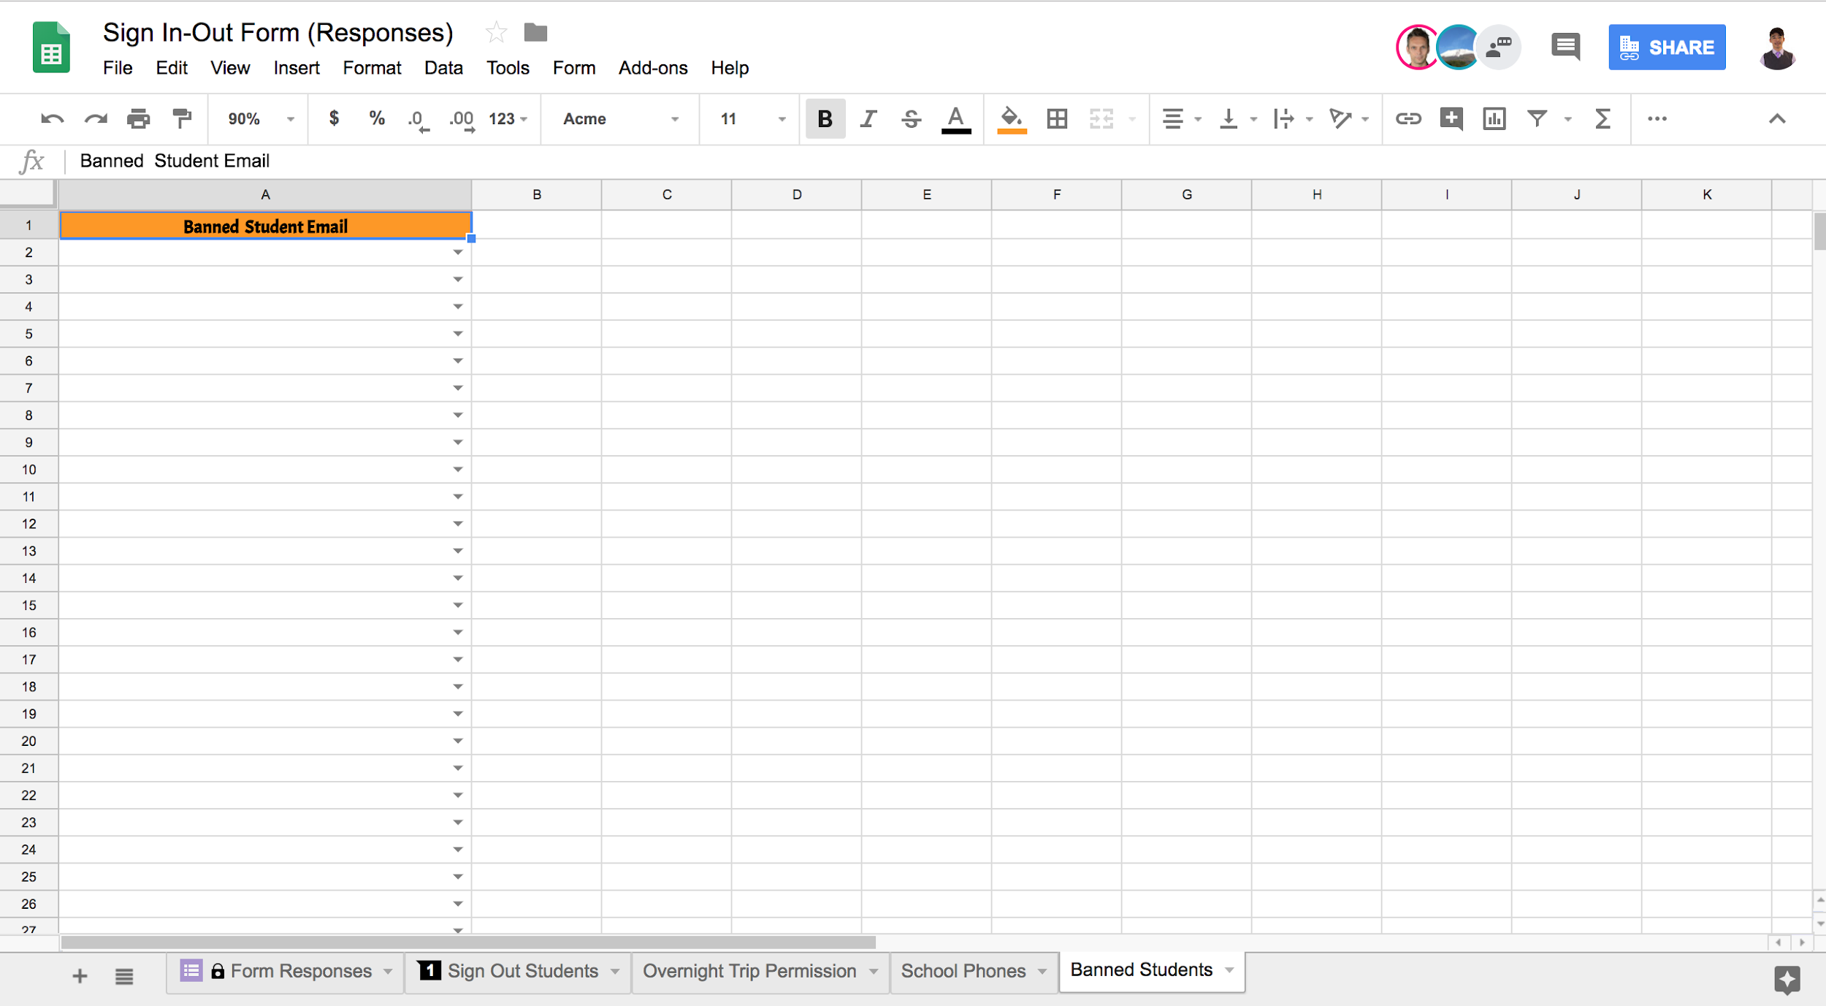

# 

# 

# 

# Data Reset Schedule

~~Automatic Data Reset~~

~~All the form responses and data in the spreadsheet will automatically deleted every one month. (can be changed if prefered).~~

Manual Data Reset

Manual Data reset can be performed by clicking on any prefered reset buttons in the ***reset*** sheet.

